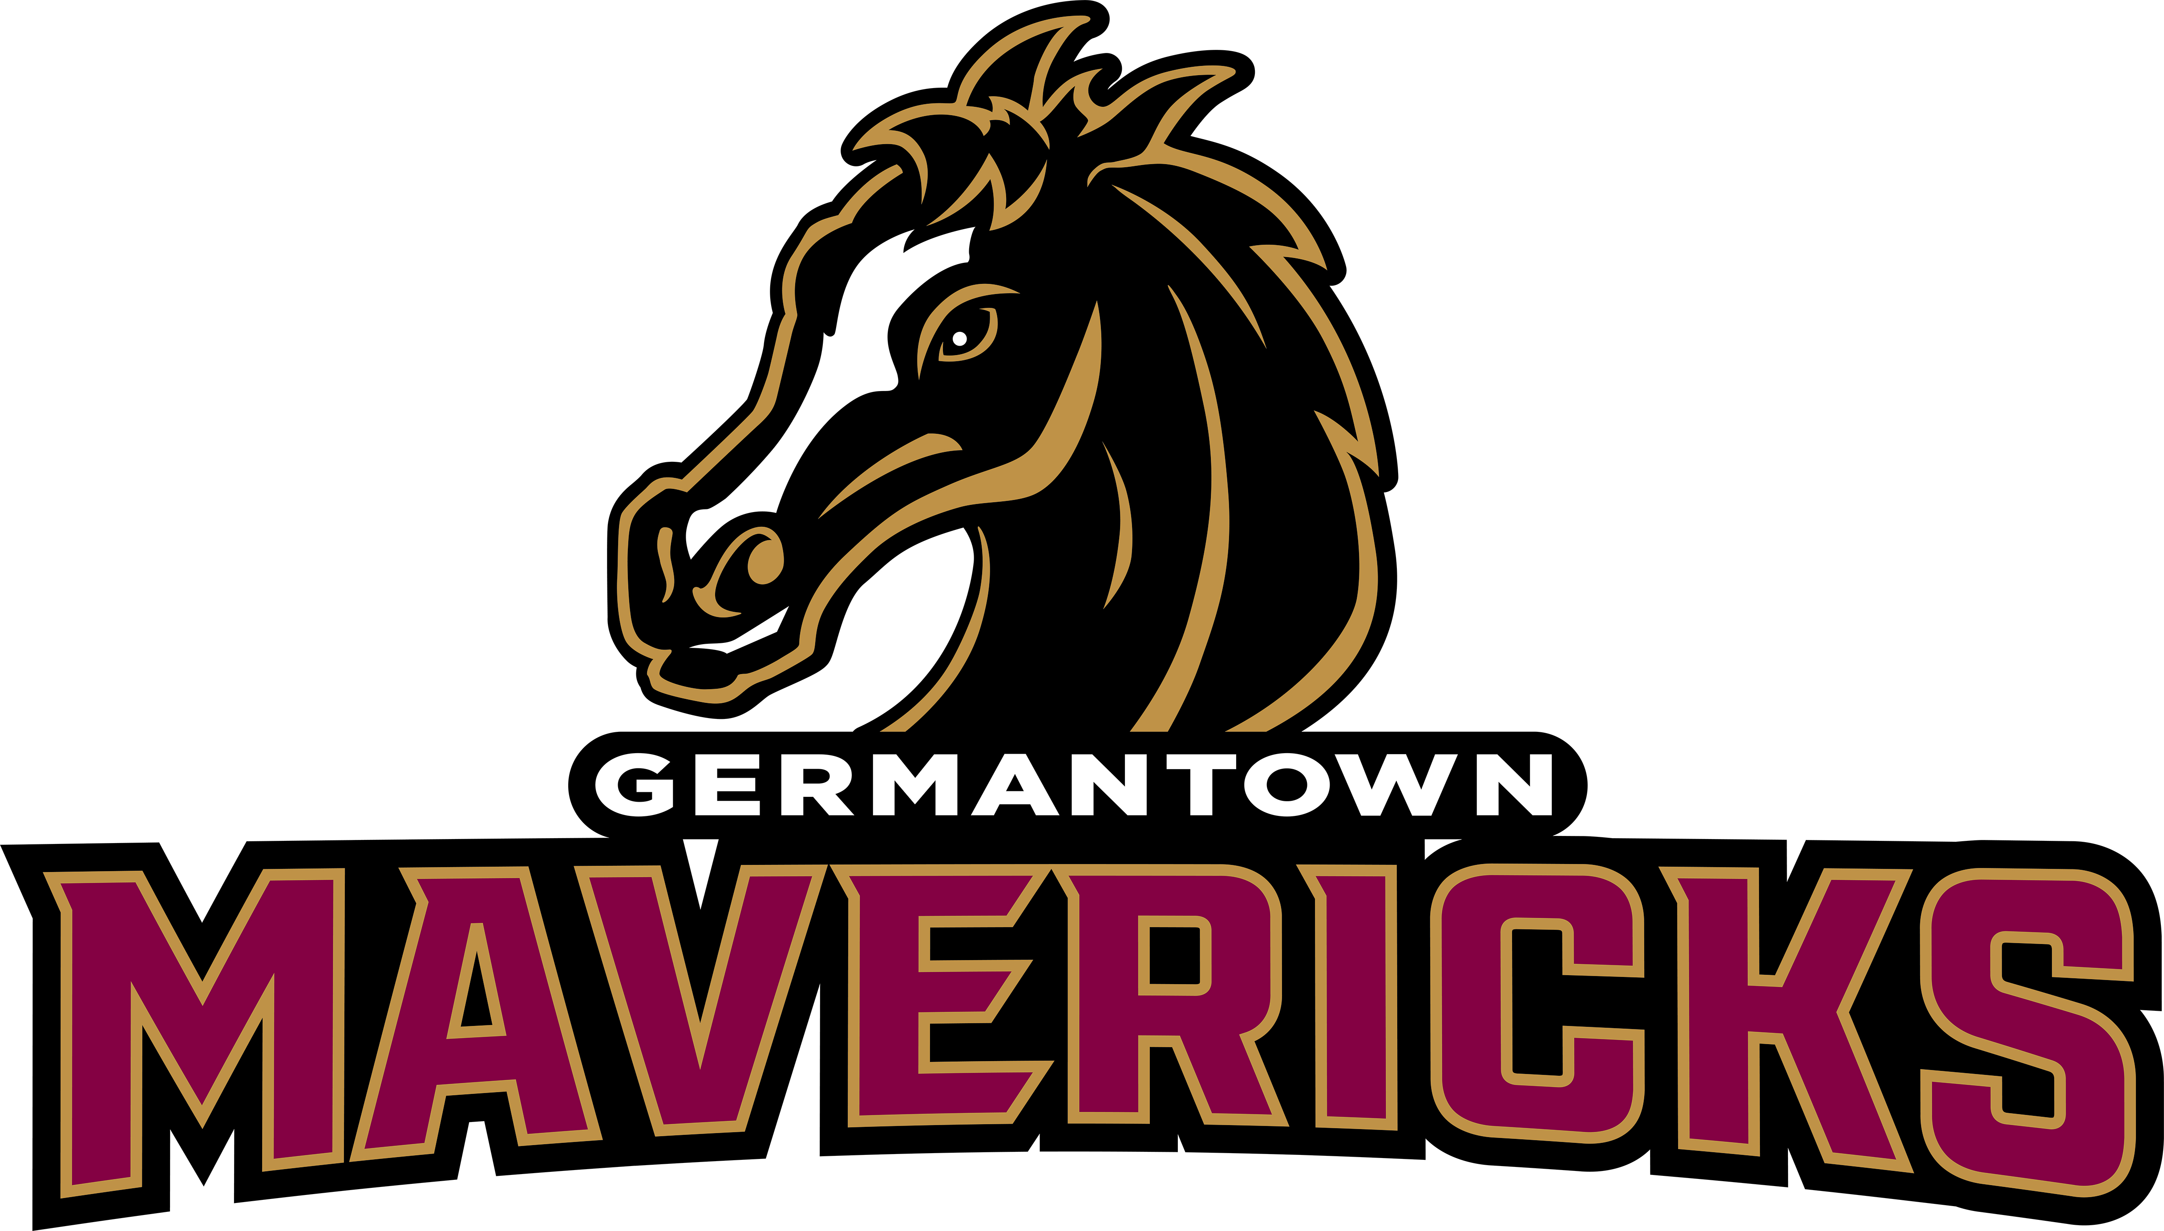
Student’s Name: (Please print clearly and check spelling)

__________________________________________

Contact Name: __________________________________________

Contact Number: _________________________

Contact Email: _________________________________________

Form of Payment: (NO CASH)

_______ GoFan (Visit gofan.co) _____ Check # (Make payable to MAVS Booster Club)

________Venmo @gomavsbooster _____ money order

Ad Prices: |  | ¼ Page black/white – 4.25 x 5.5” – $75 - 1 picture max
 |  | ½ Page black/white– 8.5” x 5.5” – $100– 2 pictures max
 |  | Full Page (black & white) – 8.5 x 11” – $200
 |  | Full Page (color) – 8.5 x 11” – $350

- Email AD and form to: ghsmavsmediaguide@gmail.com
- Print Ready Ads are preferred! Ads should be the exact dimension listed above but do not require bleeds.
- If paying by check or money order, drop it off at the GHS front office in an envelope marked MEDIA GUIDE or mail it to MAVS Booster Club, 409 Calhoun Parkway, Madison, MS 39110.
- Photos from phone-choose “largest size” when emailing
- Ads cannot be published without payment.

ADS must be submitted and paid by JUNE 15!

Thank you for your support of Germantown Maverick Athletics!

*If you have any questions, please contact Nicole Shows via email at ghsmavsmediaguide@gmail.com

**Ad Salesperson: Cheer or Dance Team Member Name_________________________________________________________

